Locate Larry

In this project you will make a “Where’s Wally?” game (“Where’s Waldo?” if you’re from the US).

You’ll use a Scratch project that generates very simple “Where’s Wally?” style pictures – mixing up cartoon characters on a random background.

You’ll use the Scratch project to train the computer to be able to spot one of the characters in the scene.

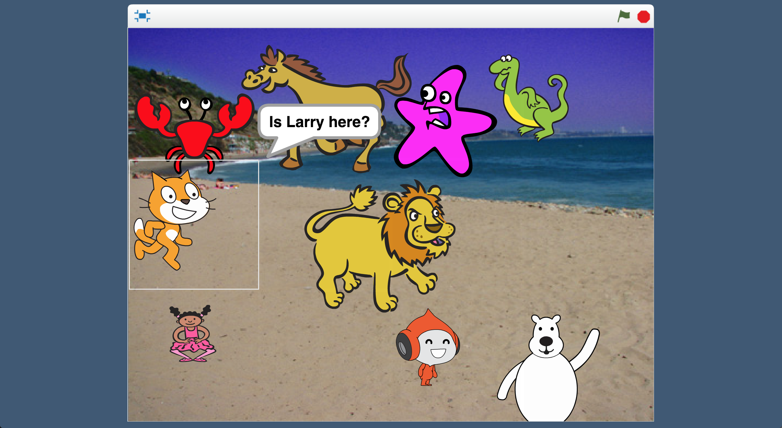

This project worksheet is licensed under a Creative Commons Attribution Non-Commercial Share-Alike License

http://creativecommons.org/licenses/by-nc-sa/4.0/

1. Choose **one** of these characters   
   *In this worksheet, I’ll choose the Scratch Cat. But choose one that you like.*   
   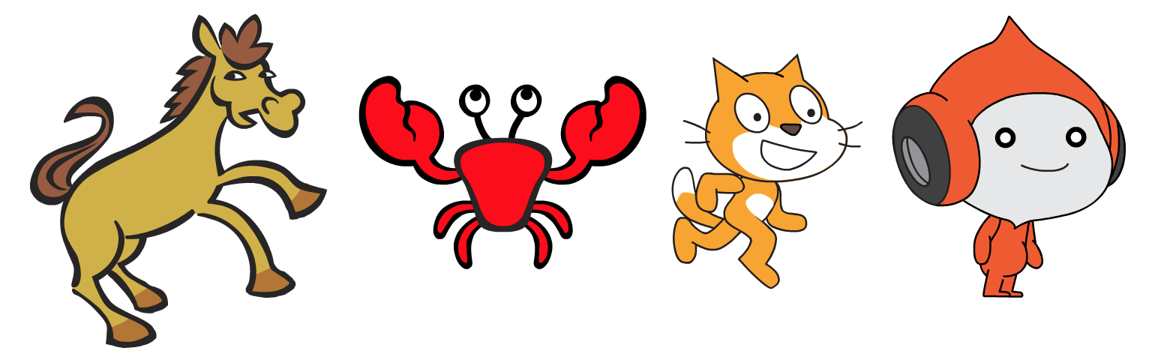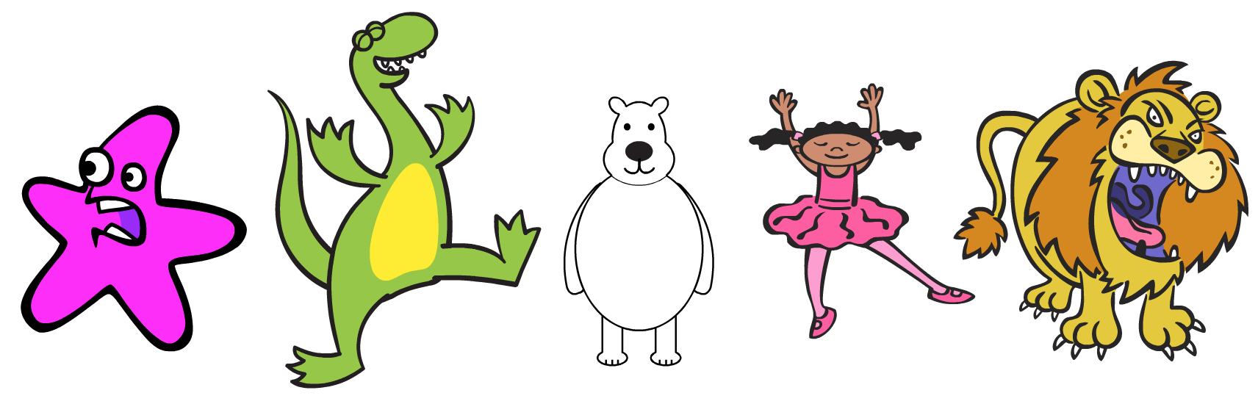
2. Think of a name for the character you chose  
   *In this worksheet, I’ll be using “Larry”. But come up with your own name.*
3. Go to <https://machinelearningforkids.co.uk/> in a web browser
4. Click on “**Get started**”
5. Click on “**Log In**” and type in your username and password  
   *If you don’t have a username, ask your teacher or group leader to create one for you.  
   If you can’t remember your username or password, ask your teacher or group leader to reset it for you.*
6. Click on “**Projects**” on the top menu bar
7. Click the **“+ Add a new project**” button.
8. Name your project “Locate Larry” and set it to learn how to recognise “**images**”. Click the “**Create**” button  
   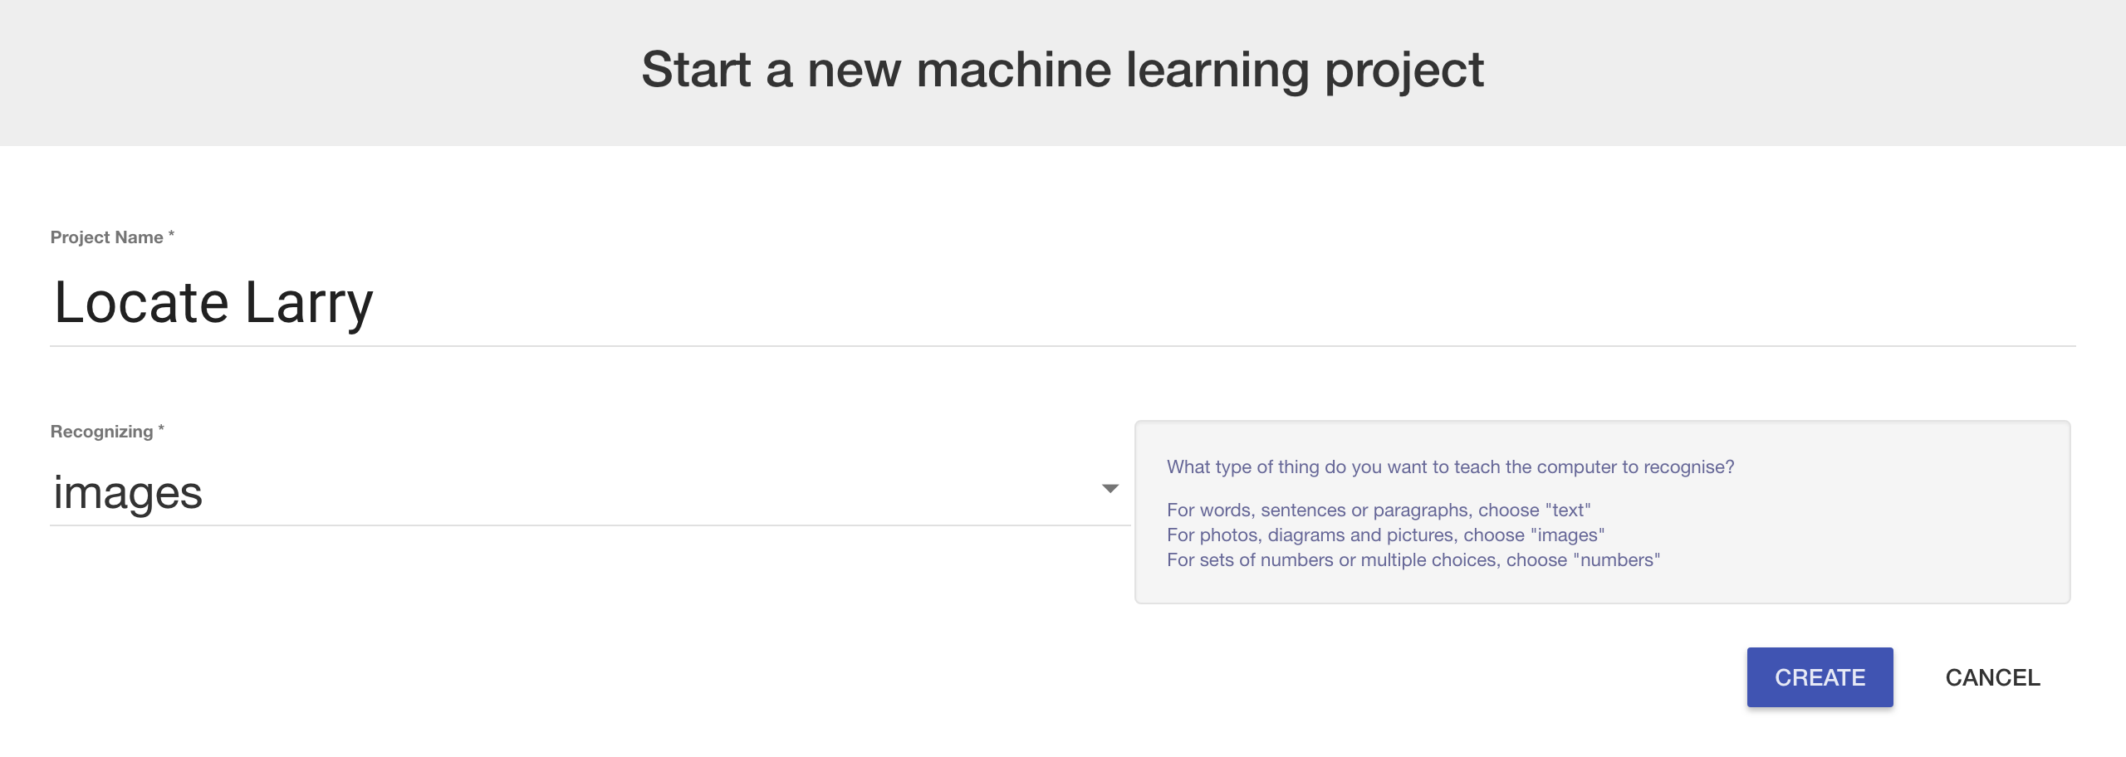
9. You should see “**Locate Larry**” in the list of your projects. Click on it.
10. Click the “**Train**” button  
    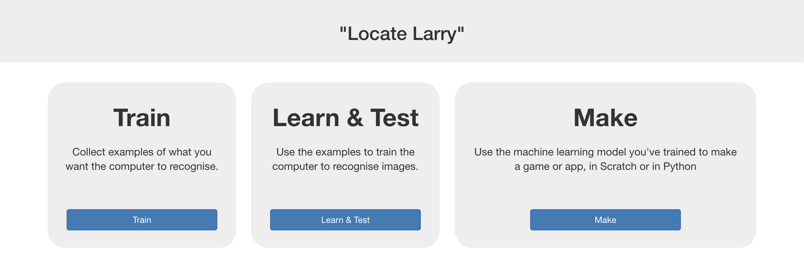
11. Click the **“+ Add new label**” button. Create a label with the name you chose for your character. (e.g. “Larry”)
12. Click “**+ Add new label**” again. Create a label with the name   
    “Not <Character Name>” (e.g. “Not Larry”)  
    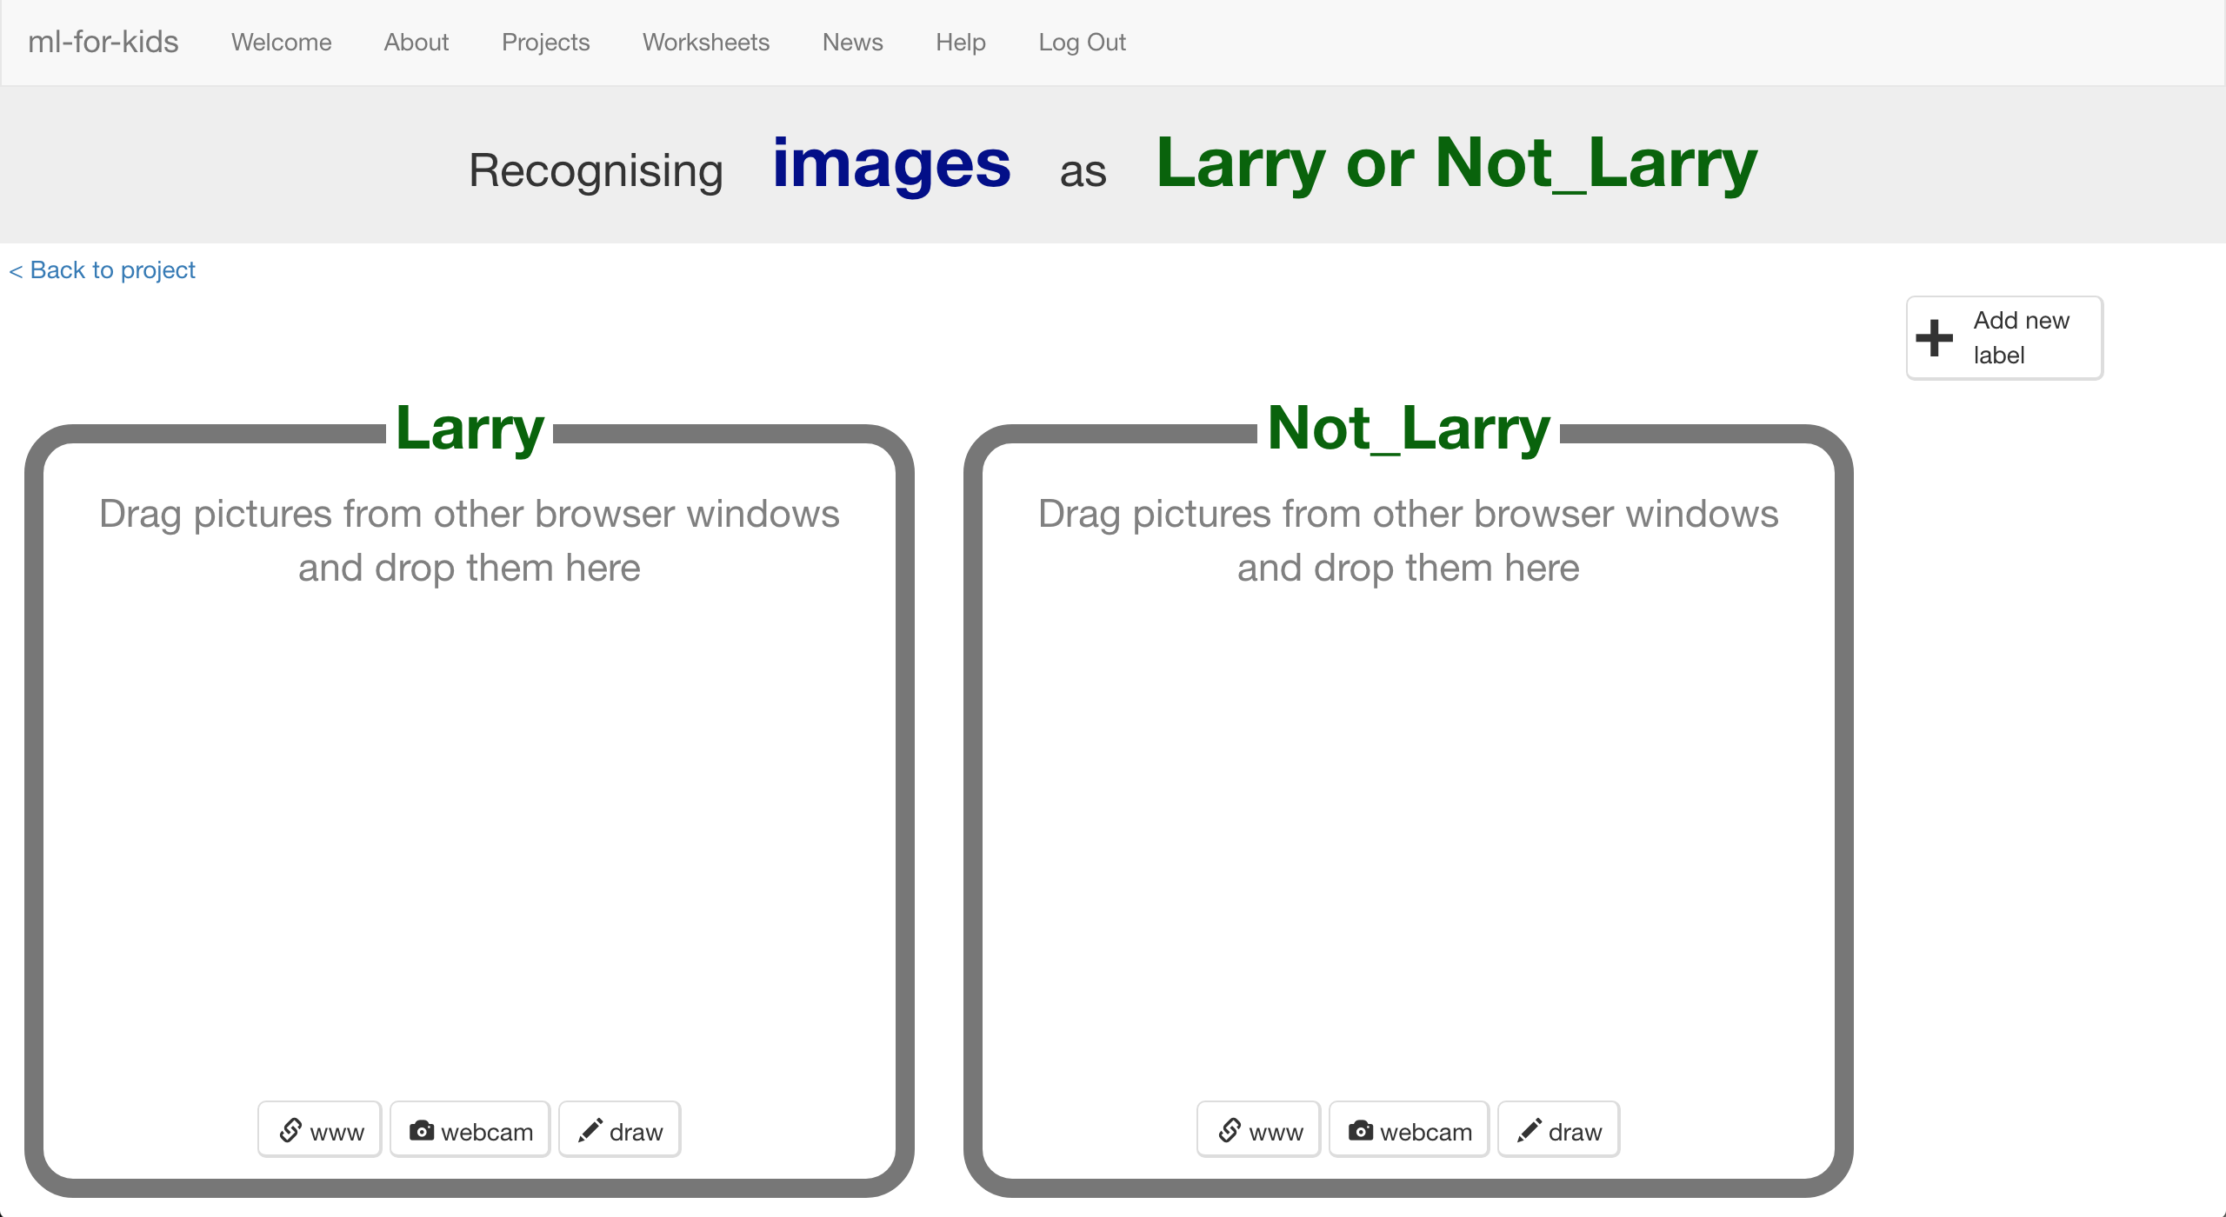
13. Click the “**< Back to project**” link
14. Click the “**Make**” button
15. Click the “**Scratch**” button
16. Click the “**straight into Scratch**” button  
    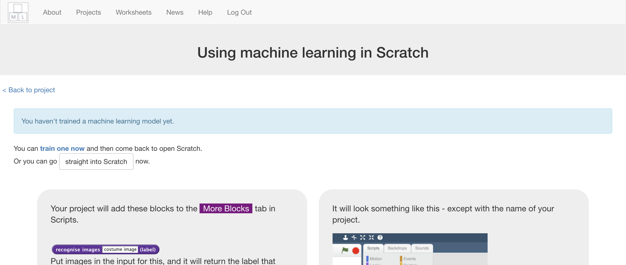
17. *You should see new blocks in the “****More blocks****” section*  
    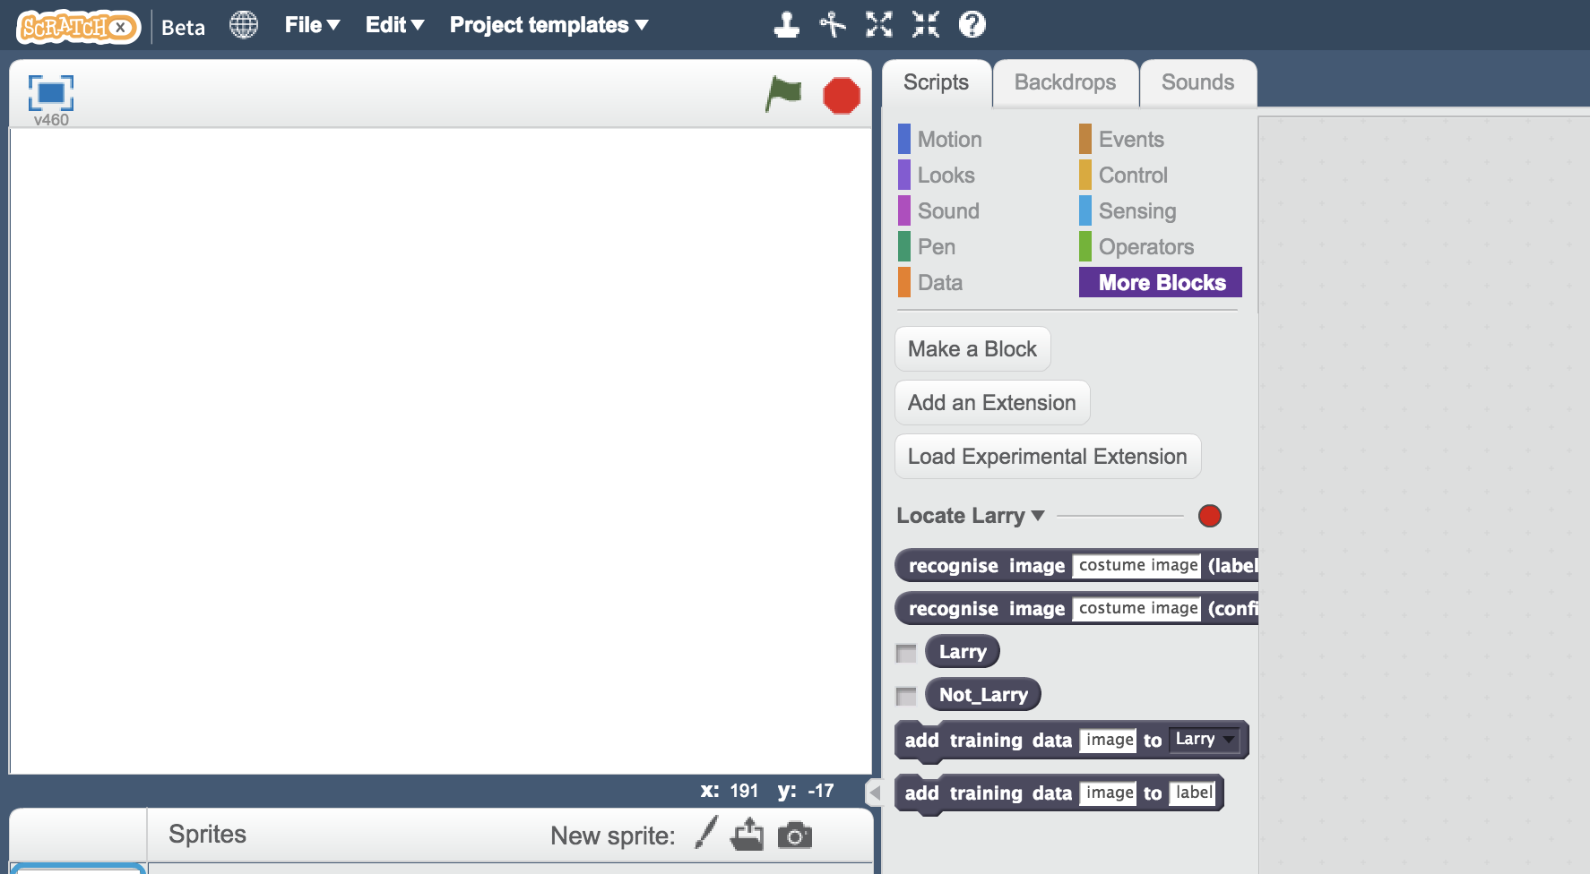
18. Open the Locate Larry project template  
    *Click “****Project templates****” -> “****Locate Larry****”*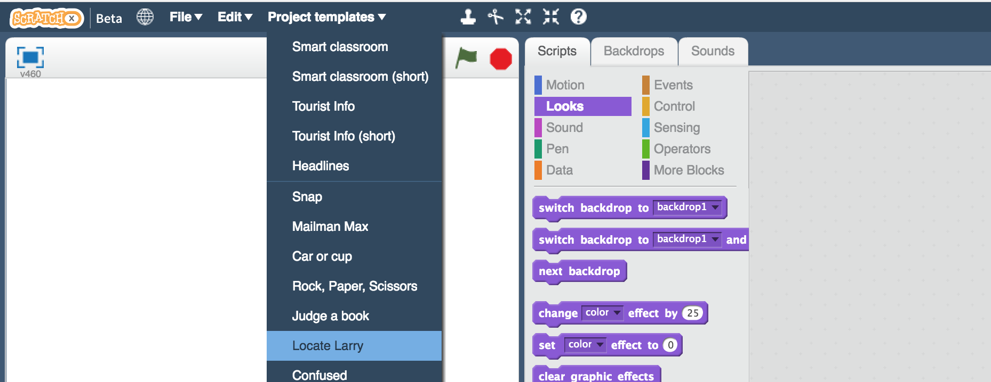
19. Click on the “**0,0**” sprite, and find the “**store HIT**” script  
    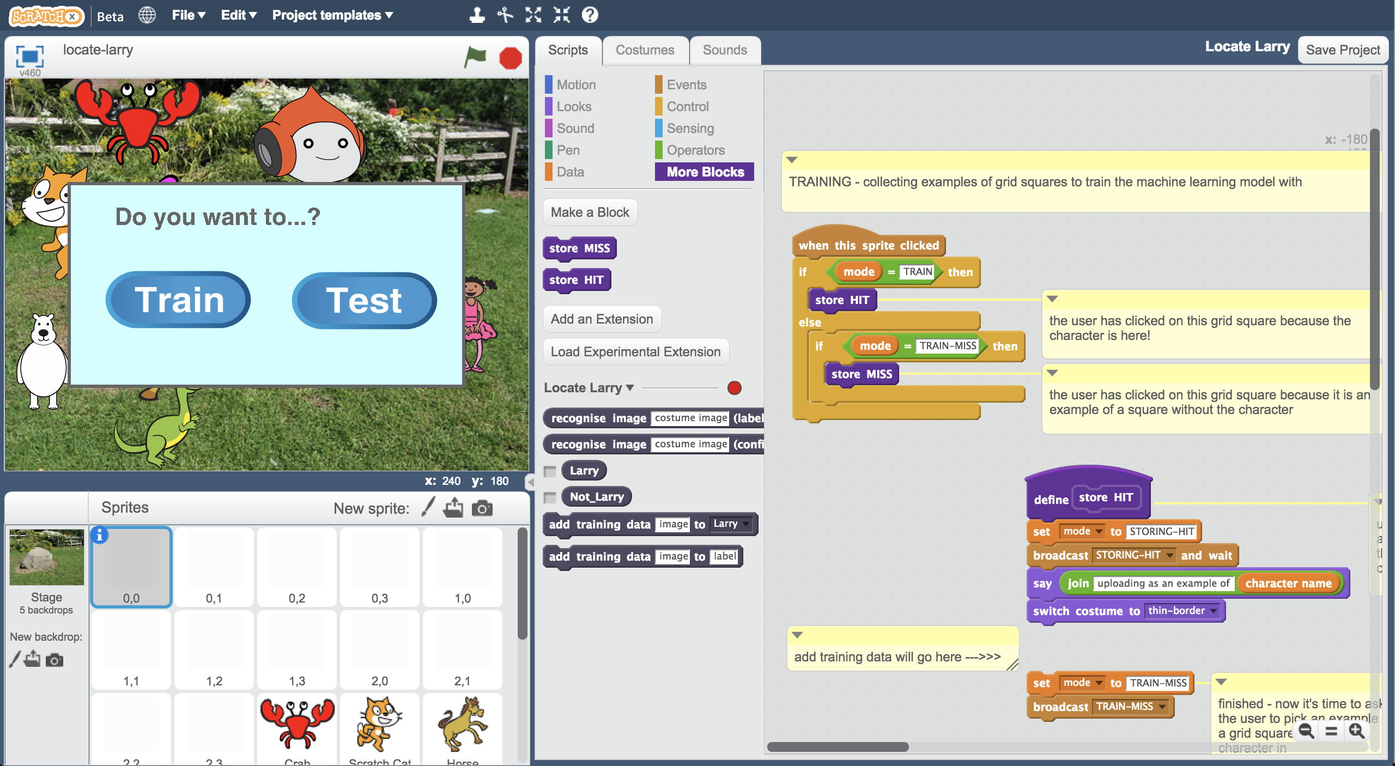
20. The “add training data will go here” comment is there to show you where you need to add a new block in the next step.   
    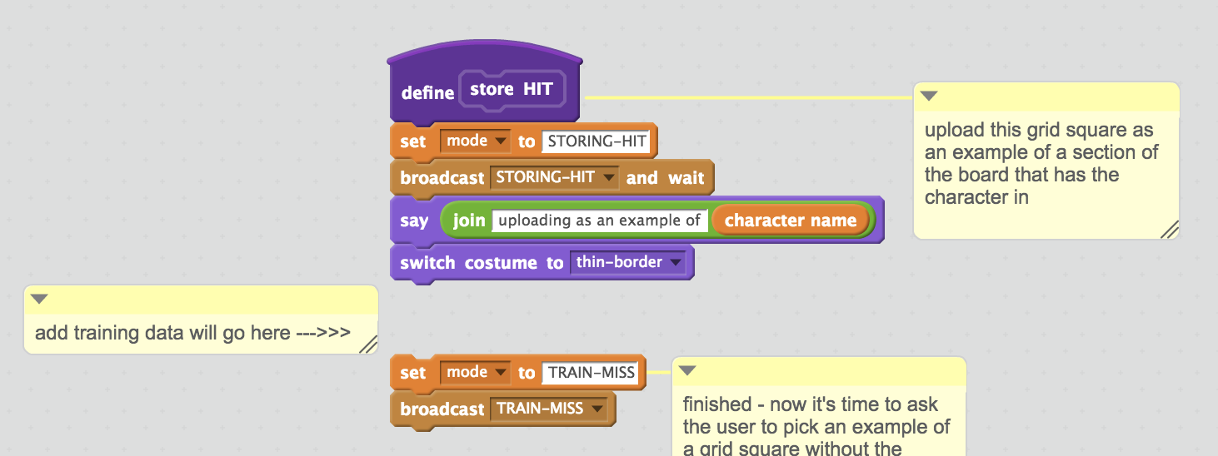
21. Add the “**add training data**” block and join it all up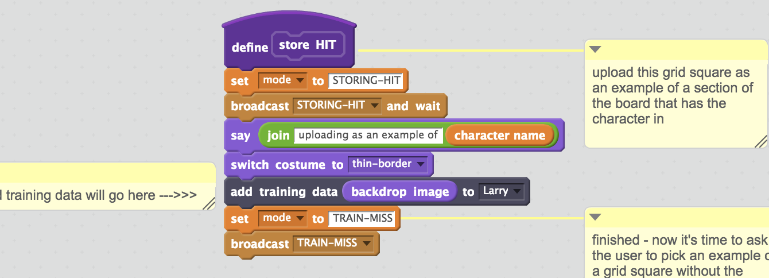
22. Find the “**store MISS**” block script.   
    *It should be just underneath “store HIT” – you might need to scroll down.*
23. Put another “**add training data**” block where the comment is, like before. This time, you should use “Not Larry” instead of “Larry”  
    *This will be the name you’ve chosen, not “Larry”.   
    Make sure you join the script up again.*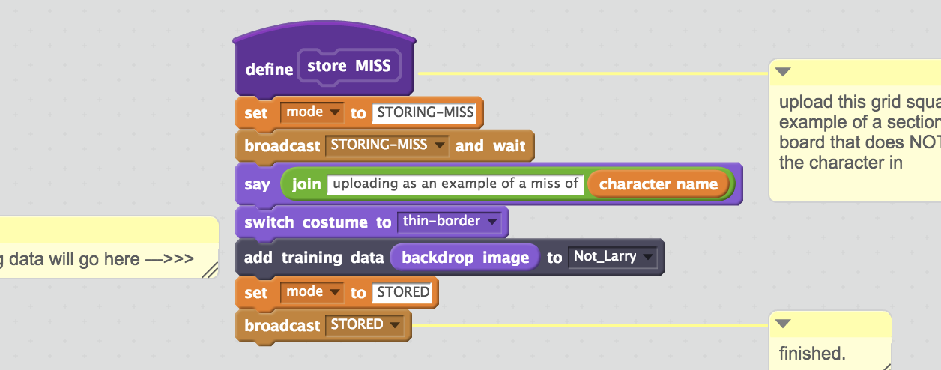
24. Do that again for all the other grid square sprites:  
    0,1 0,2 0,3 1,0 1,1 1,2 1,3 2,0 2,1 2,2 2,3  
      
    You need to do all twelve sprites that look like grey squares.  
     *Remember: choose “****Name”*** *of your character in “store* ***HIT****” and   
     choose “****Not******Name****” of your character in “store* ***MISS****”*
25. Click on “**Stage**” and type your character name in the script   
    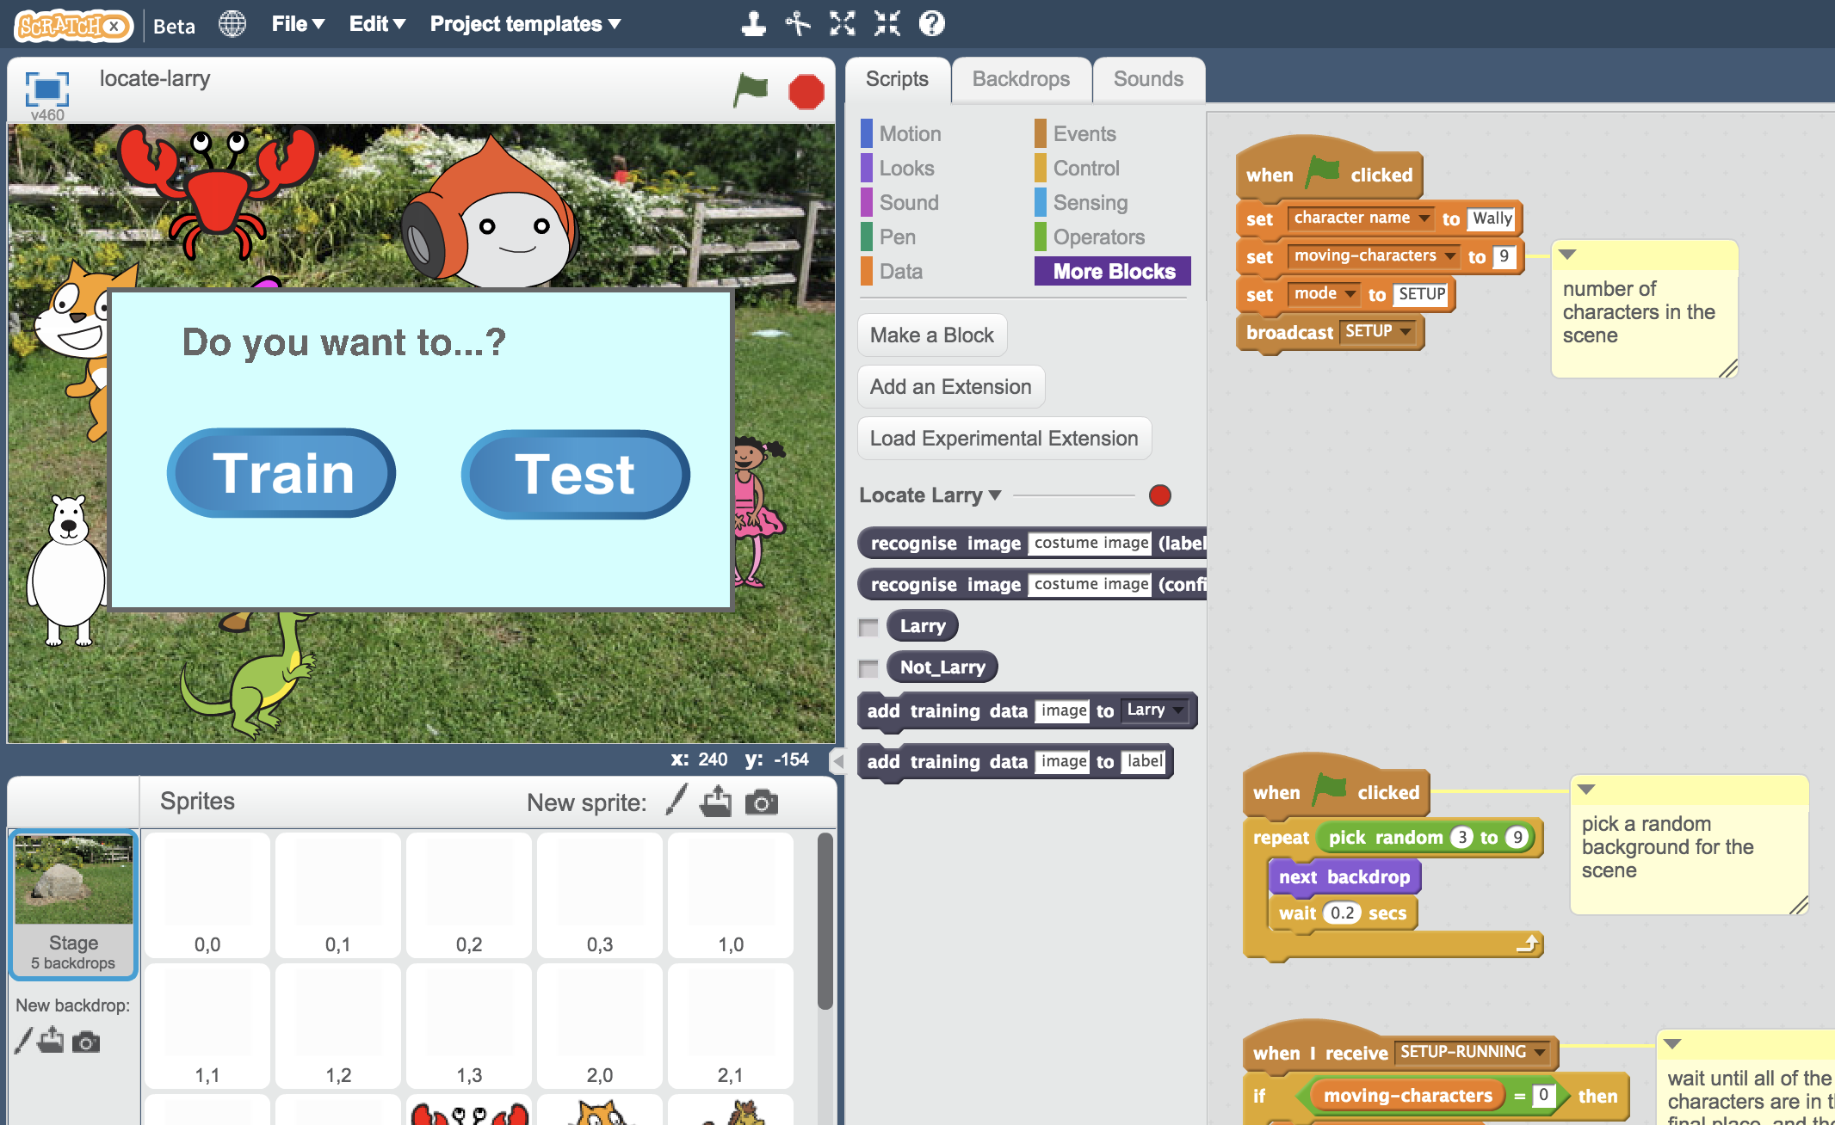
26. Click on “full screen” and then click the Green Flag  
    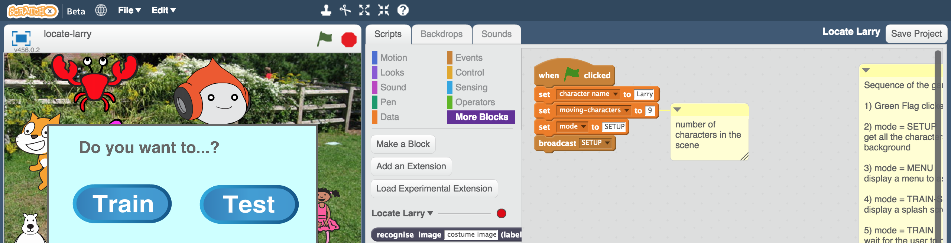
27. The script will pick a random background, and shuffle the characters (choosing a random size, position and costume for them).   
    Click “**Train**”  
    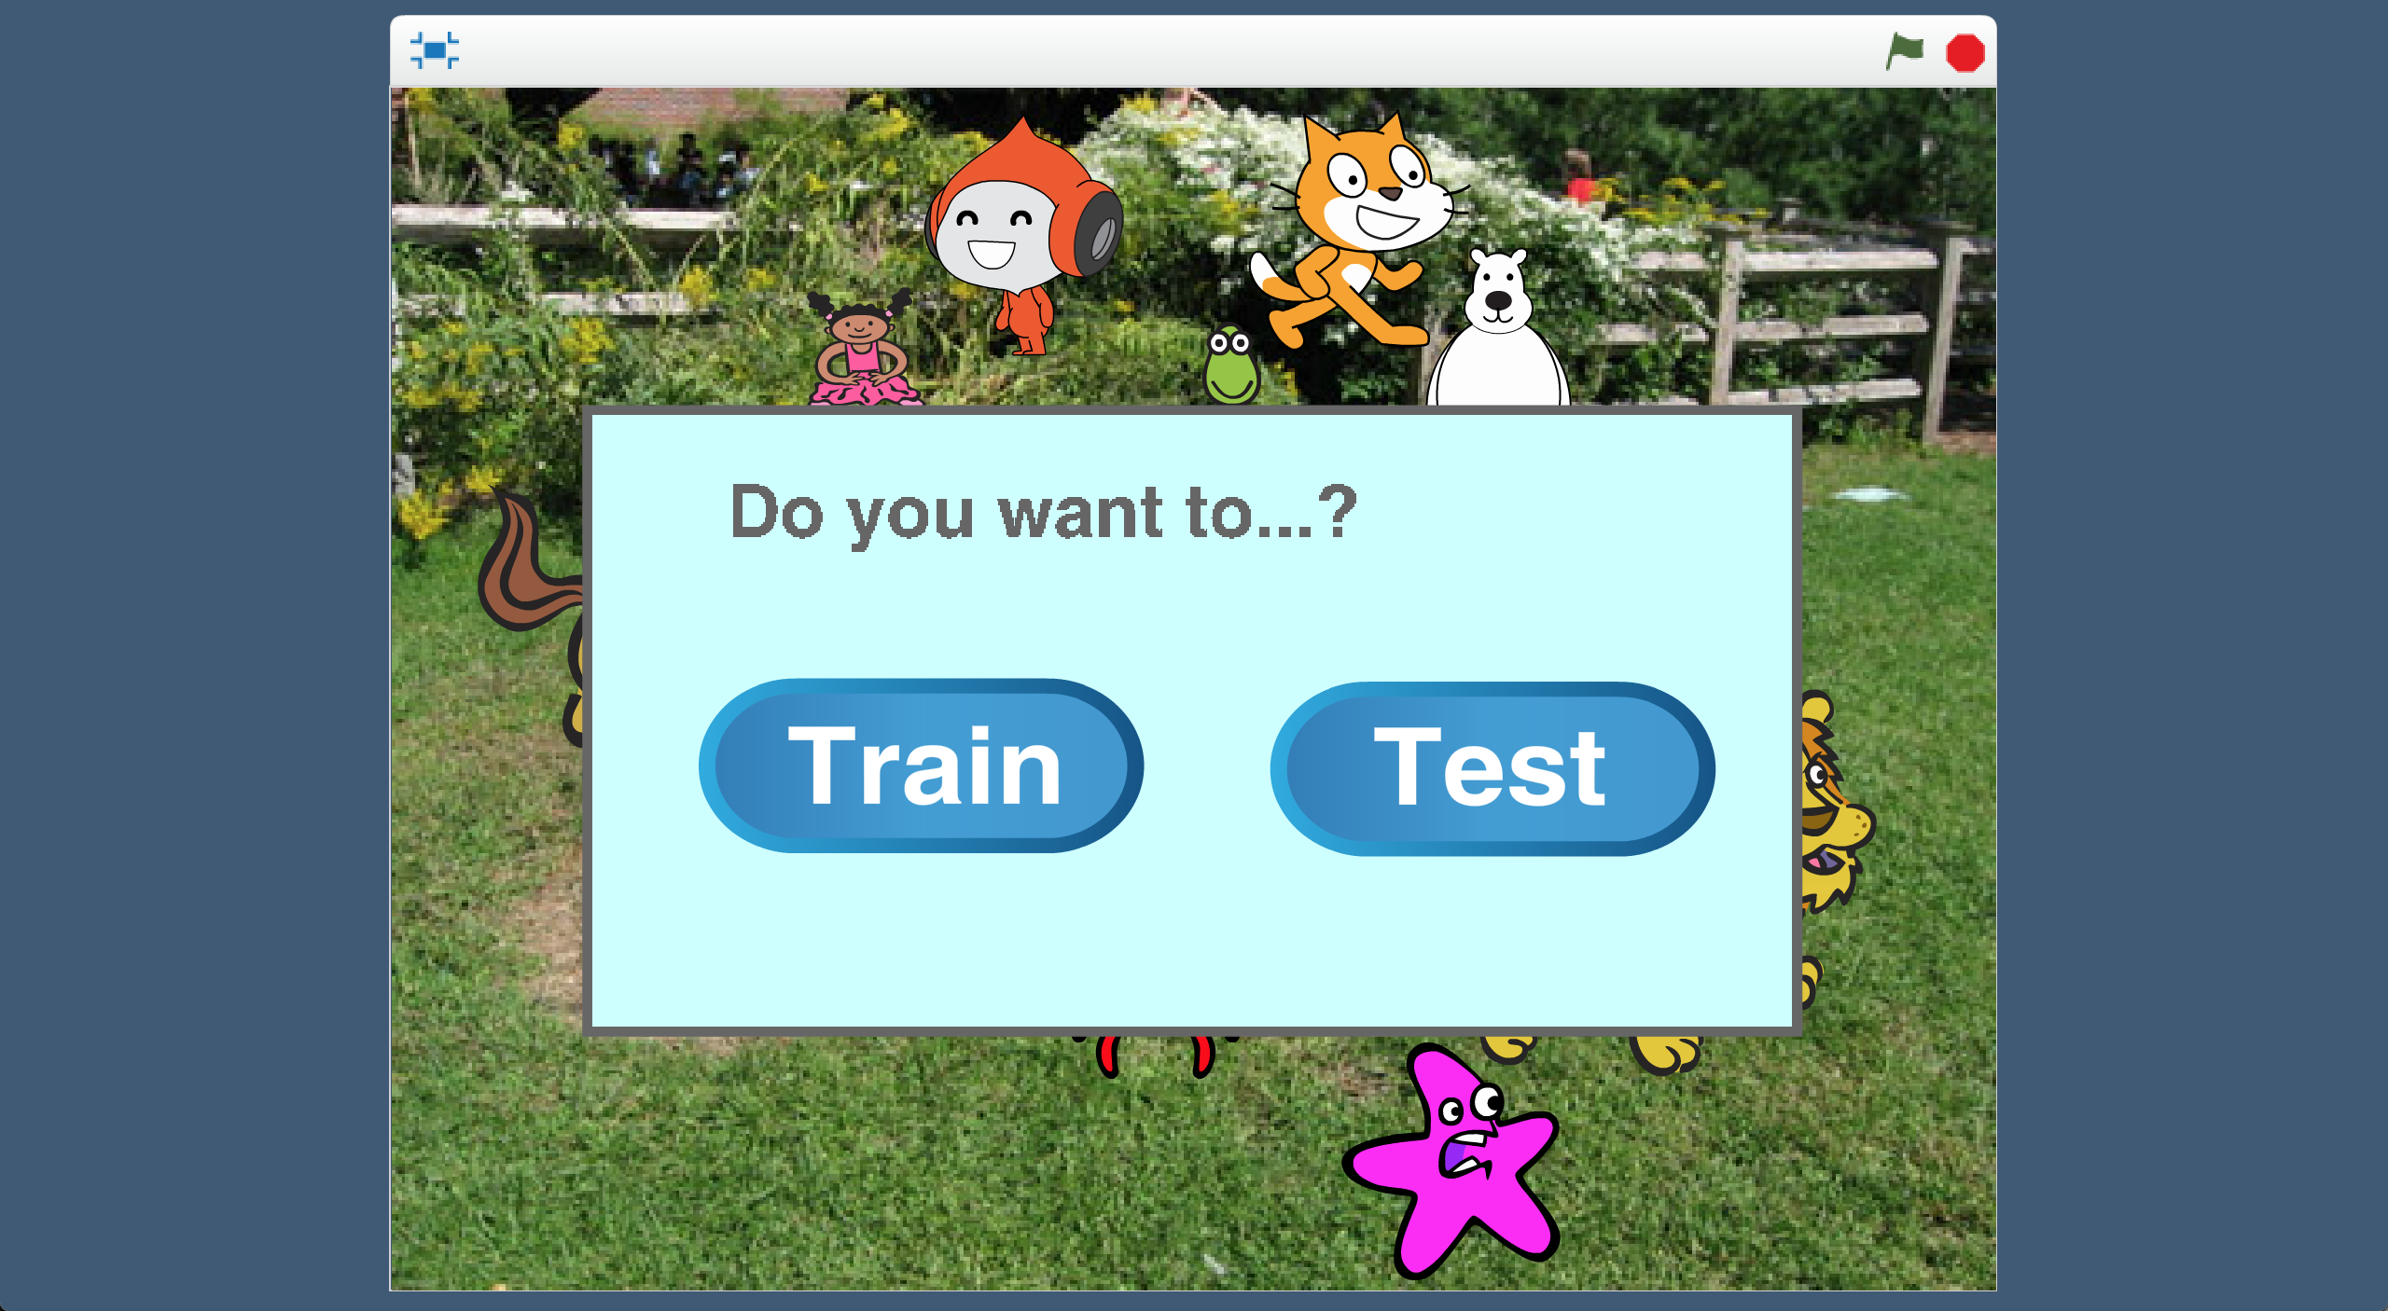  
      
    Click “**OK**”

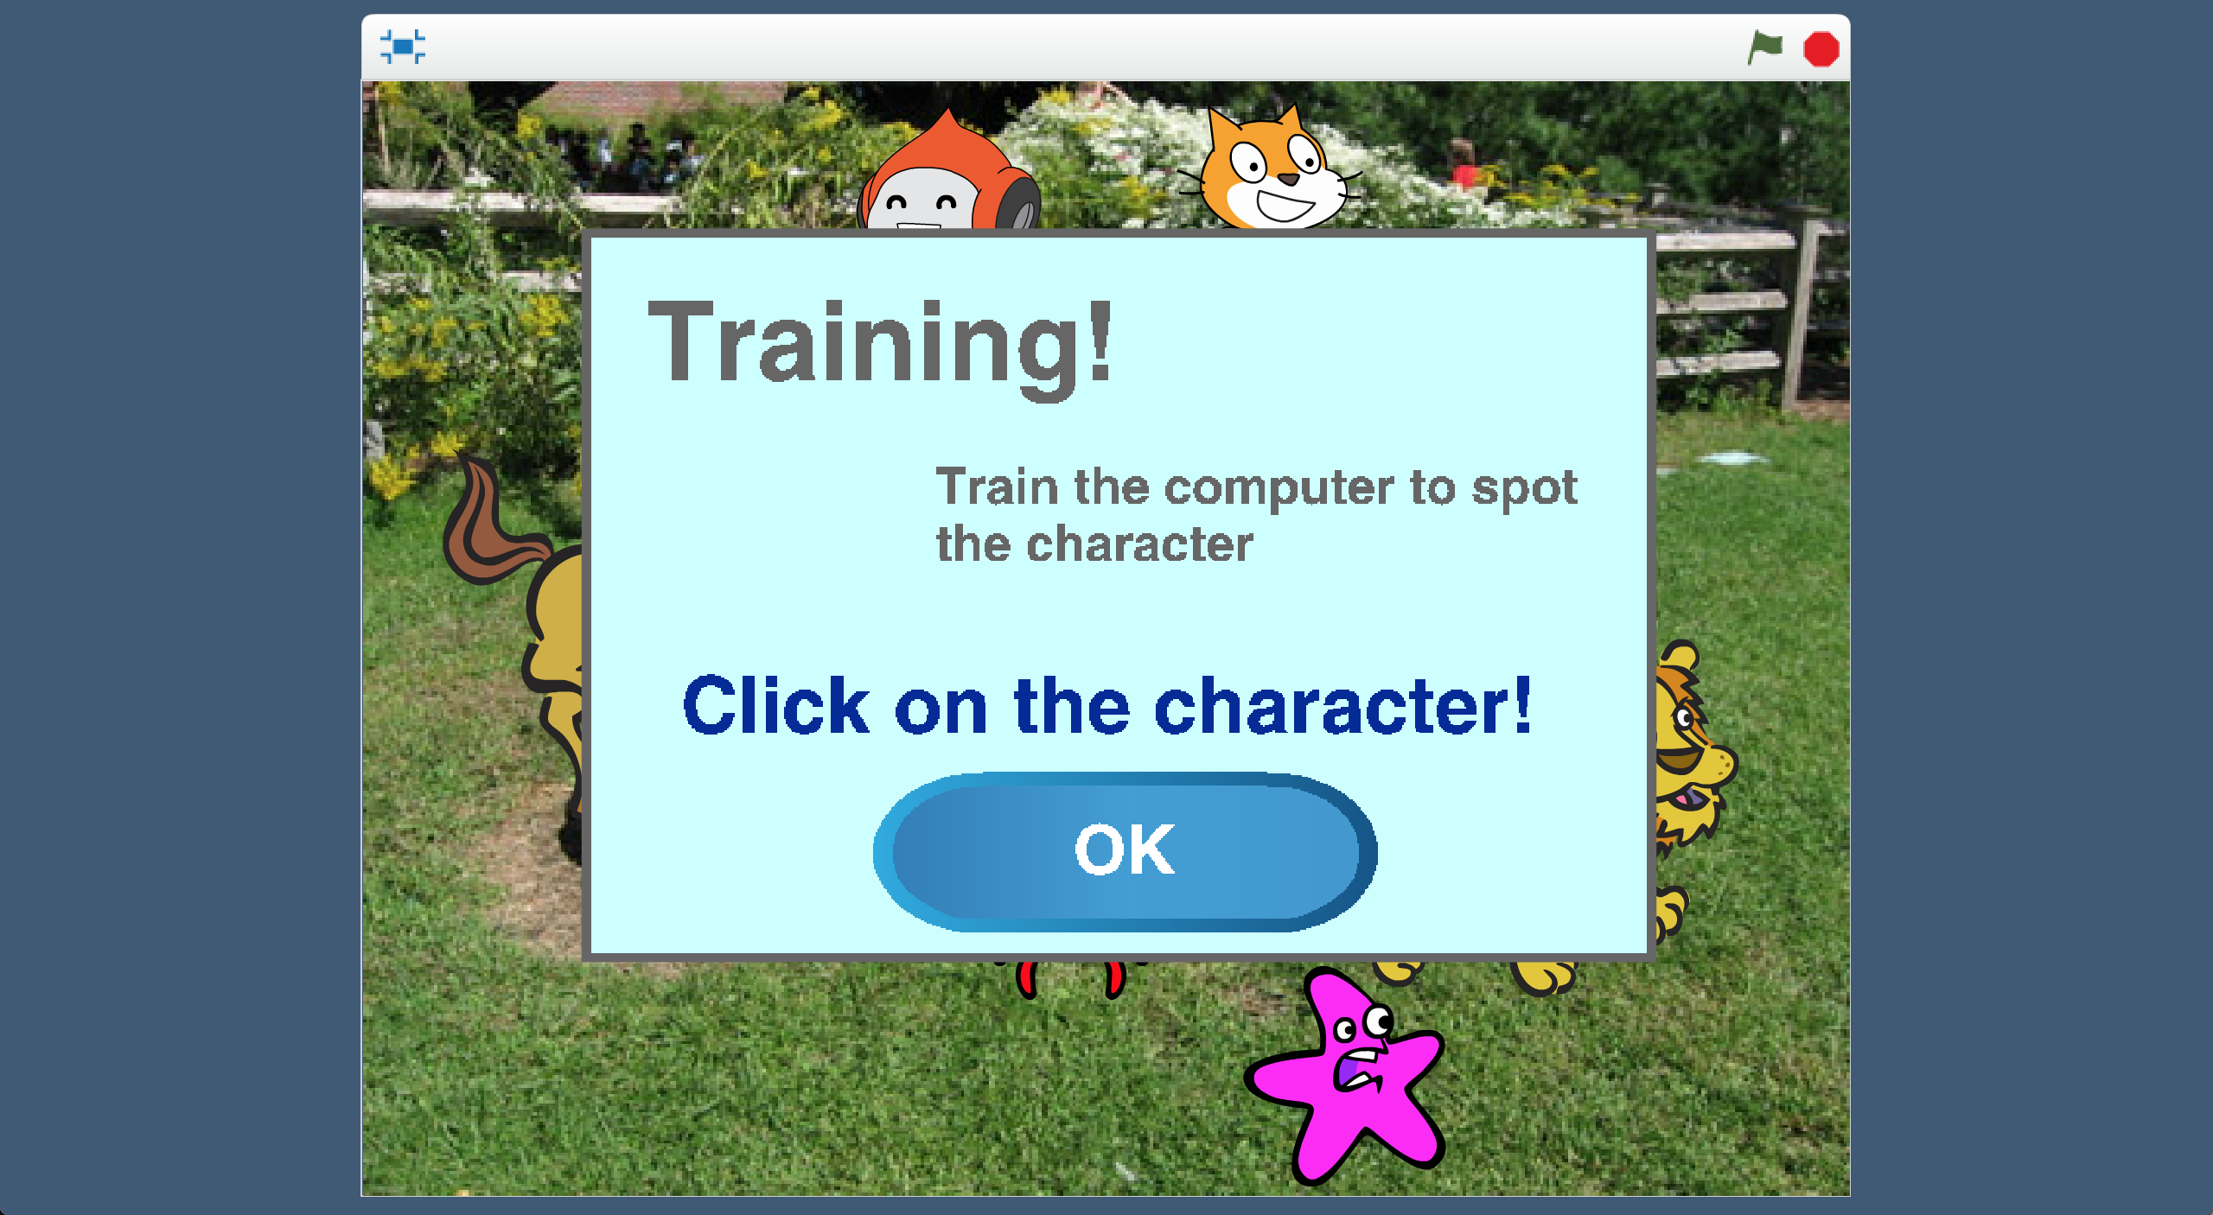

1. Click on the character that you chose before  
   *We’re training the computer how to find the character you chose – so clicking on it will collect an example of what they look like.*   
   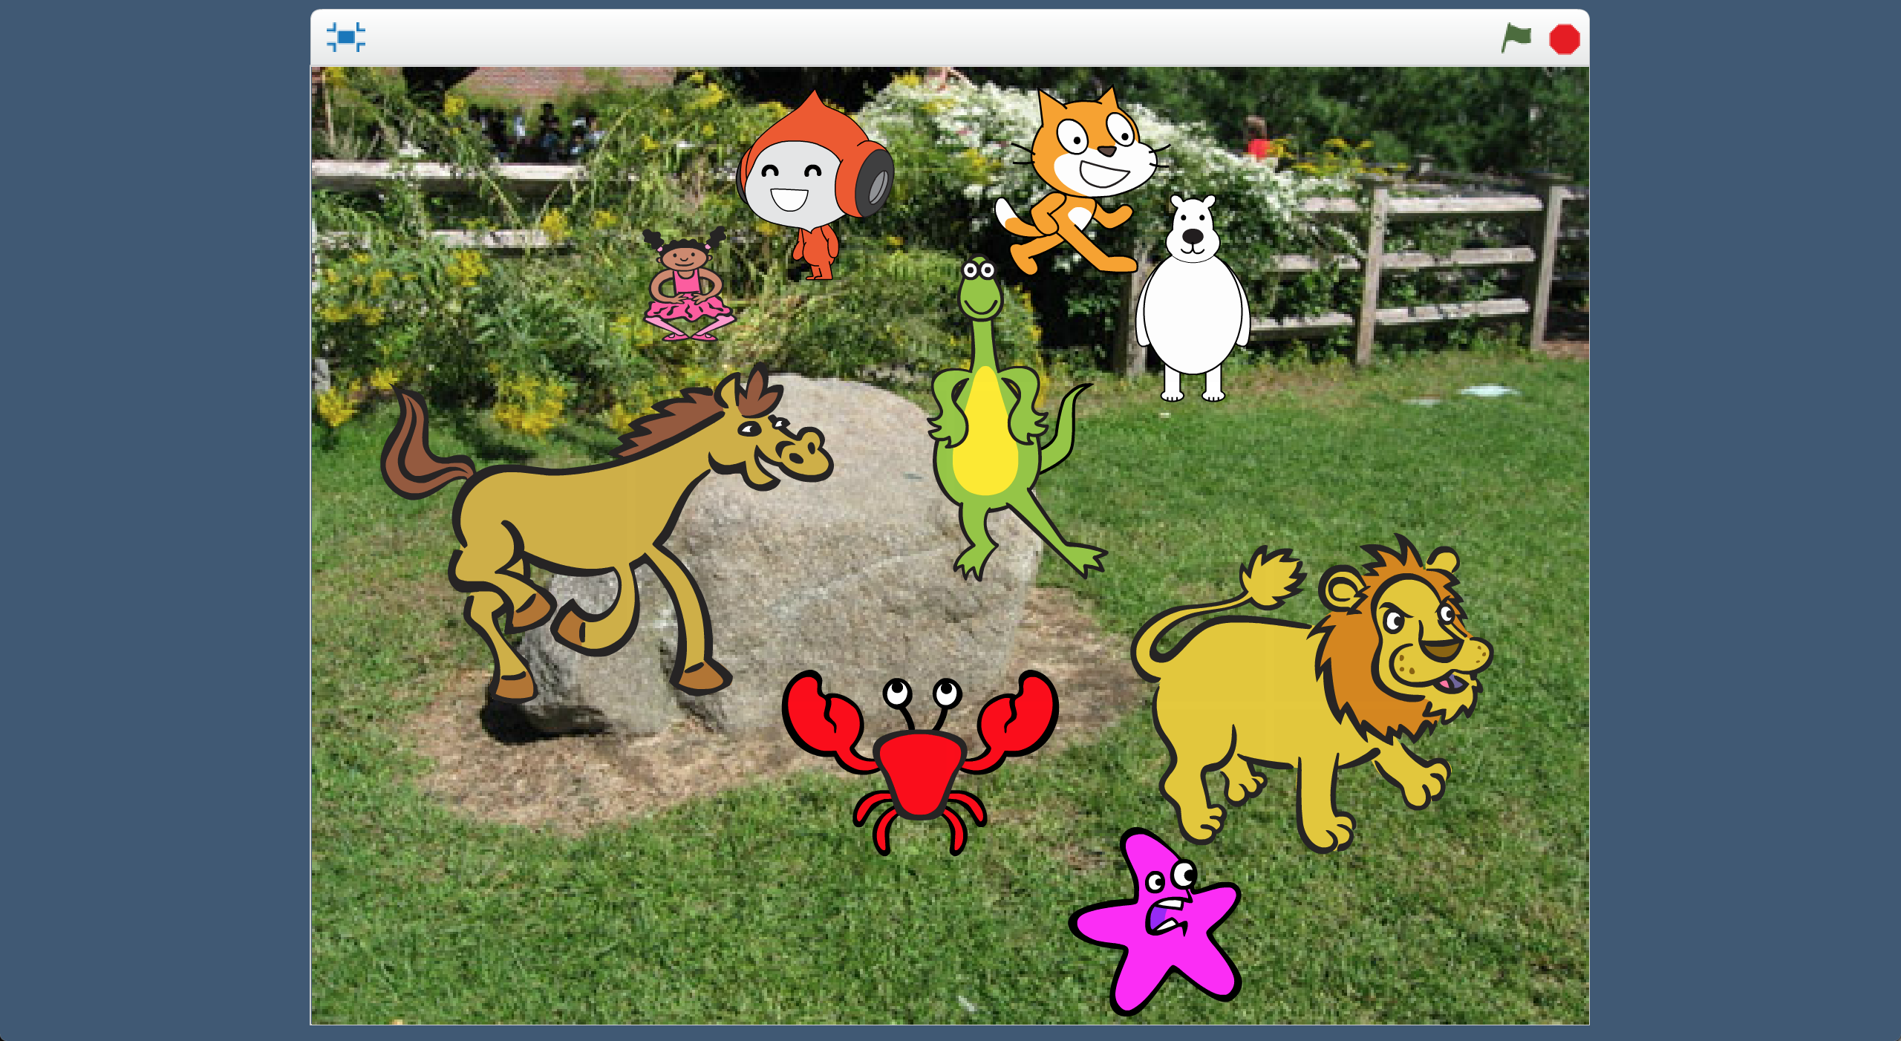

e.g. click here

1. Next, you need to collect an area of the stage that **doesn’t** have your character. *Click “OK”*   
   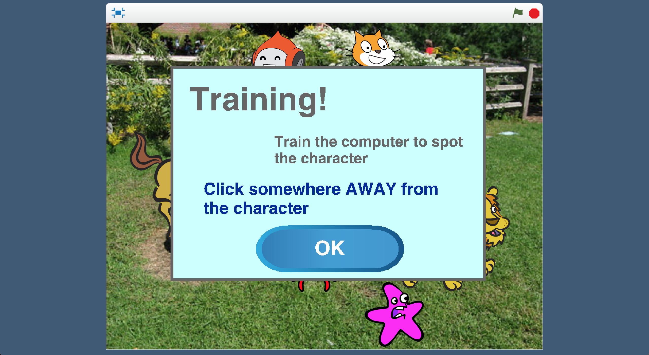
2. Click any area that your character definitely isn’t in  
   **
3. Go back to the main training tool window. *(Leave Scratch open!)*  
   Click “**< Back to project**” and then click the “**Train**” button.   
   *You should see the two training images from Scratch*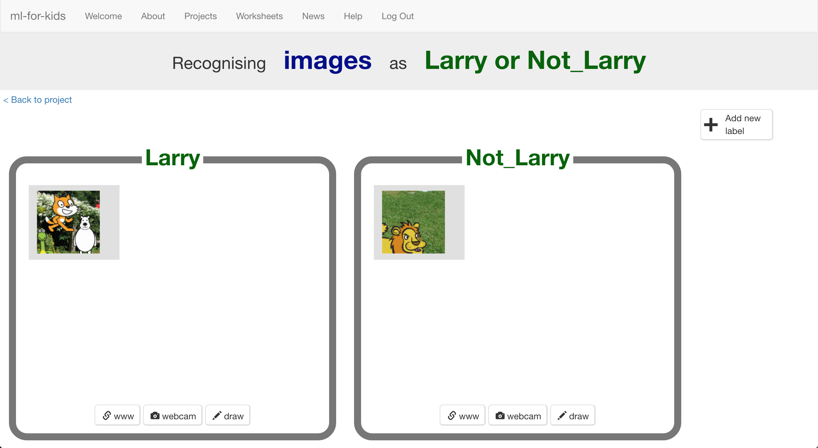
4. Go back to the Scratch window. Click the Green Flag and start again.  
   *Repeat and collect* ***ten (pairs of)*** *examples.*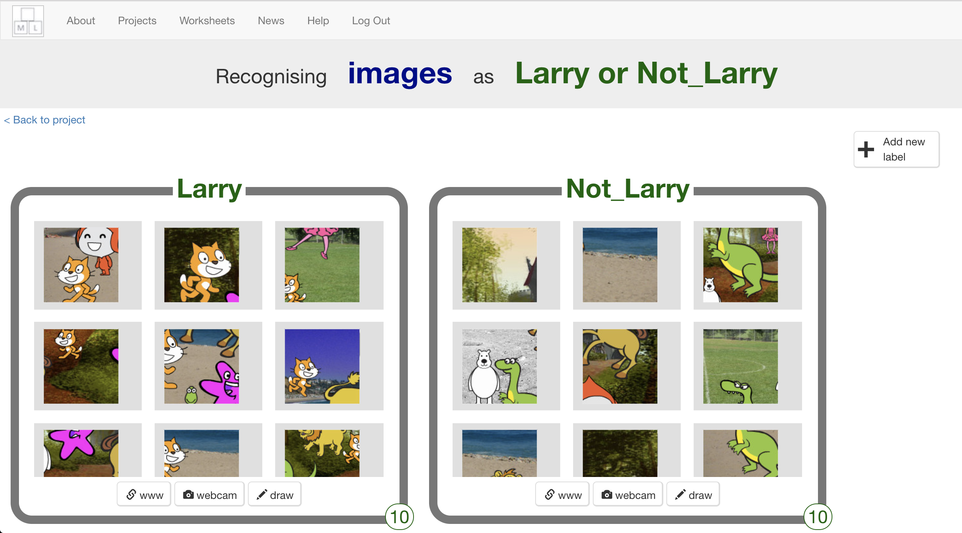
5. Save your Scratch project   
   *Click “****File****” -> “****Save project****”*
6. Click “**< Back to project**” and then click the “**Learn & Test**” button
7. Click the “**Train new machine learning model**” button  
   *The computer should start to learn how to recognise your character.*  
   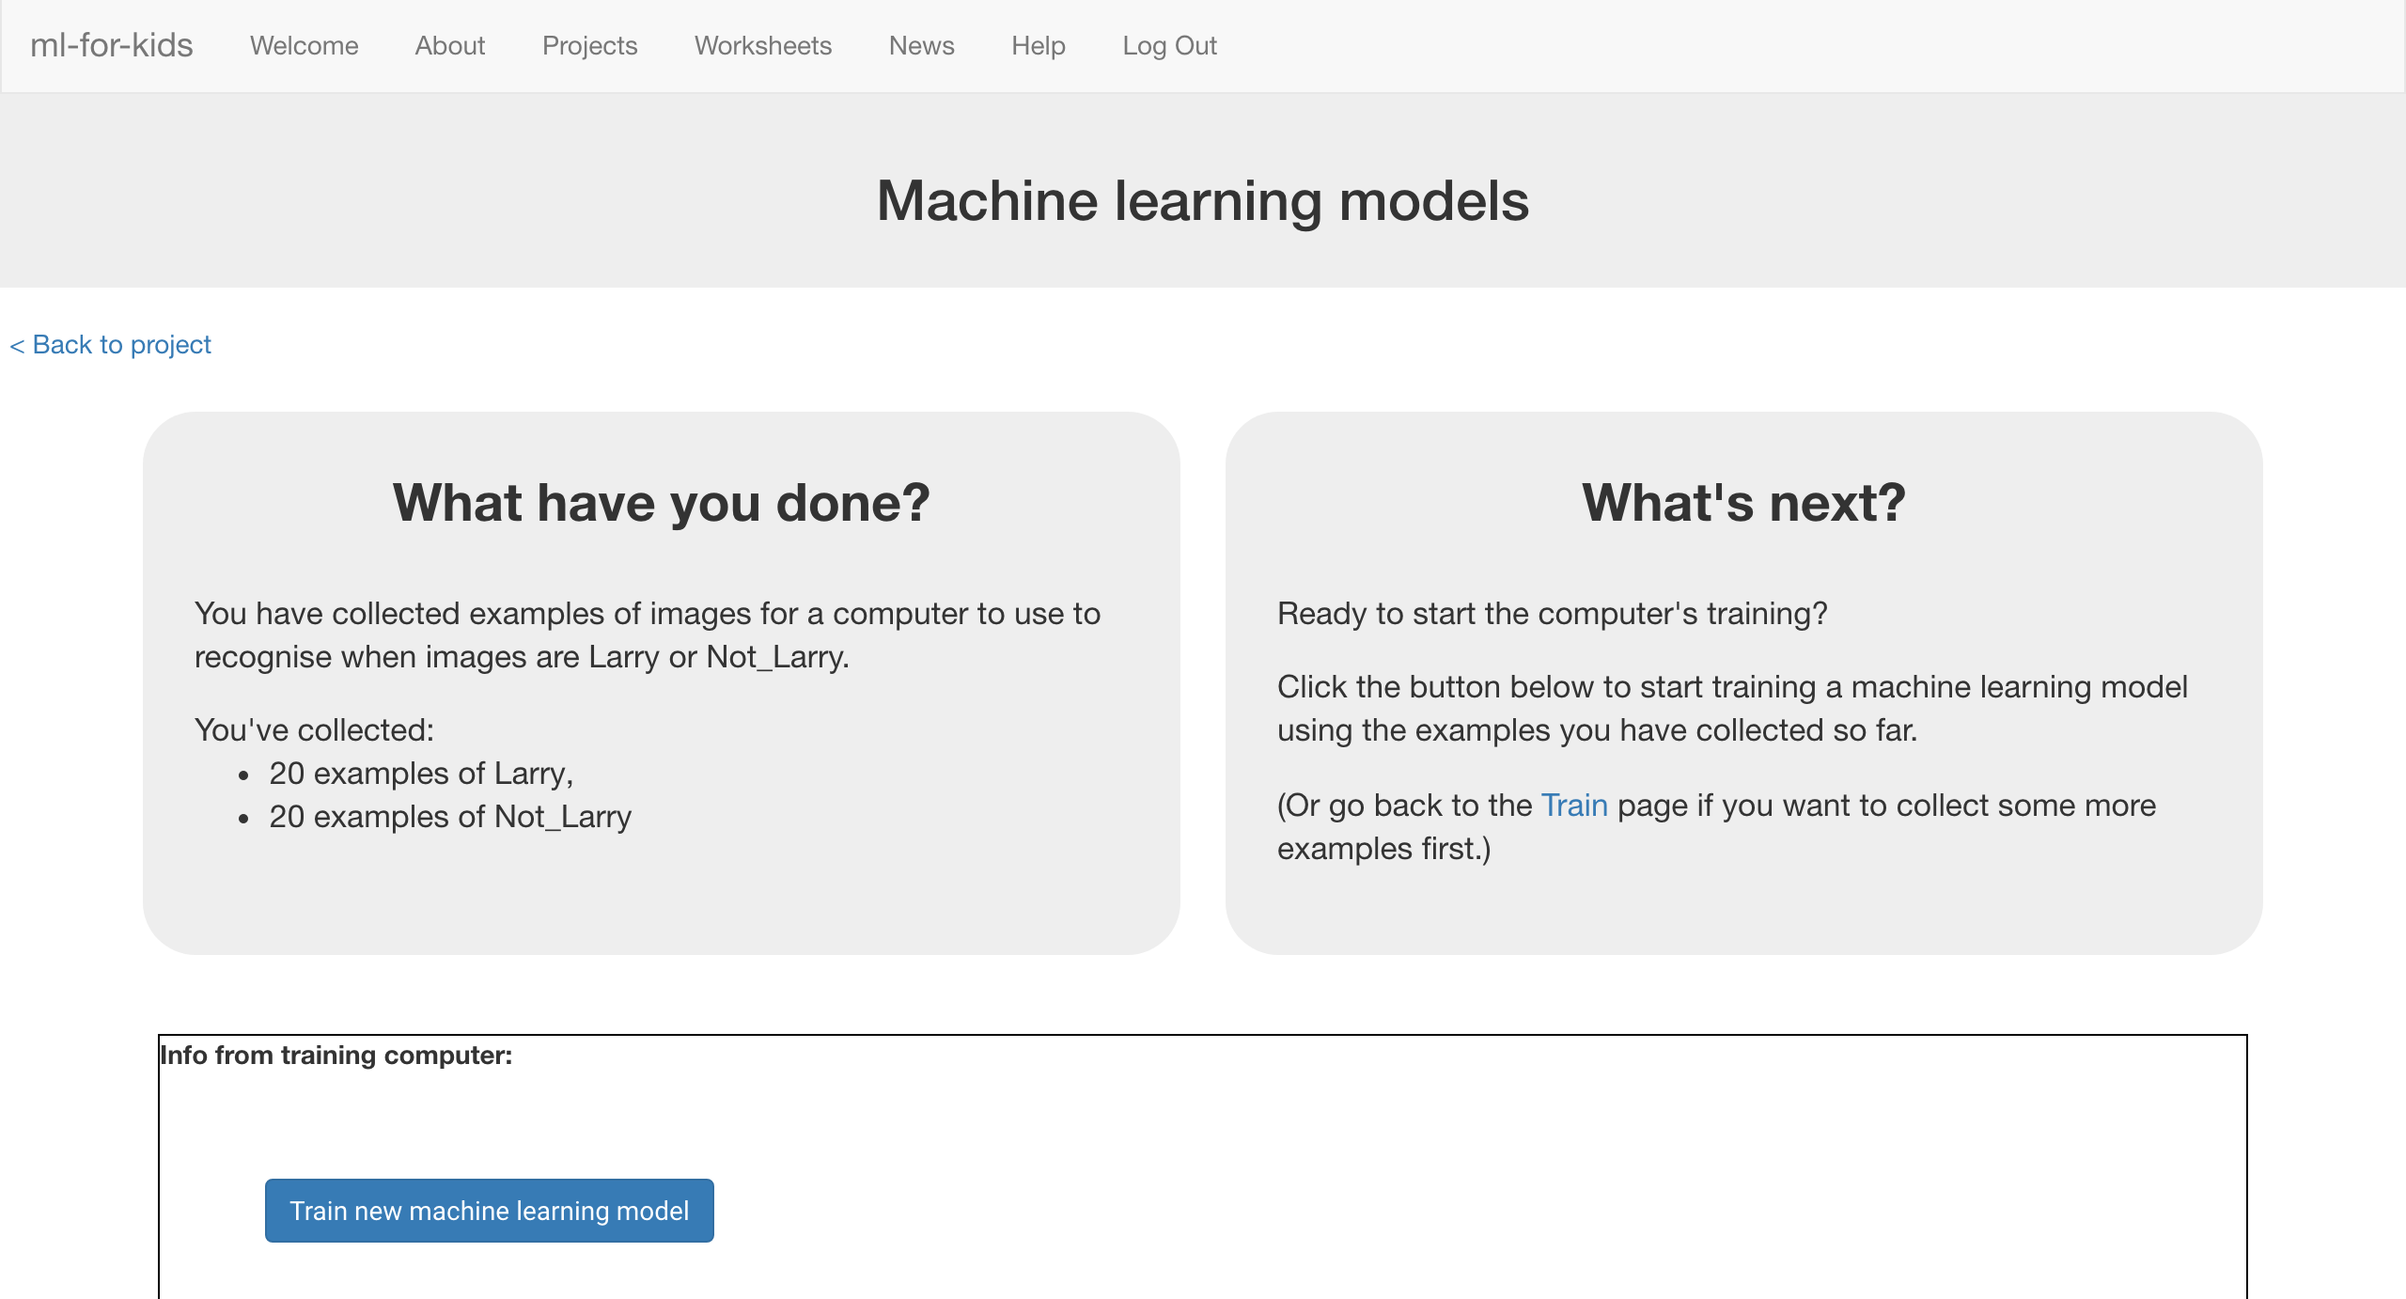
8. Switch back to the Scratch window.   
   *If you accidentally closed it, you can get back to it by doing this:  
   * Click the “****< Back to project****” link  
   * Click the “****Make****” button  
   * Click the “****Scratch****” button, and then click the “****Open in Scratch****” button  
   * Open the Scratch project you saved before, with “****File****” -> “****Load Project****”*
9. Click the “**0,0**” sprite, and find the “**when I receive TEST-0,0**” script  
   *It will be at the very bottom. You might need to scroll down to it.*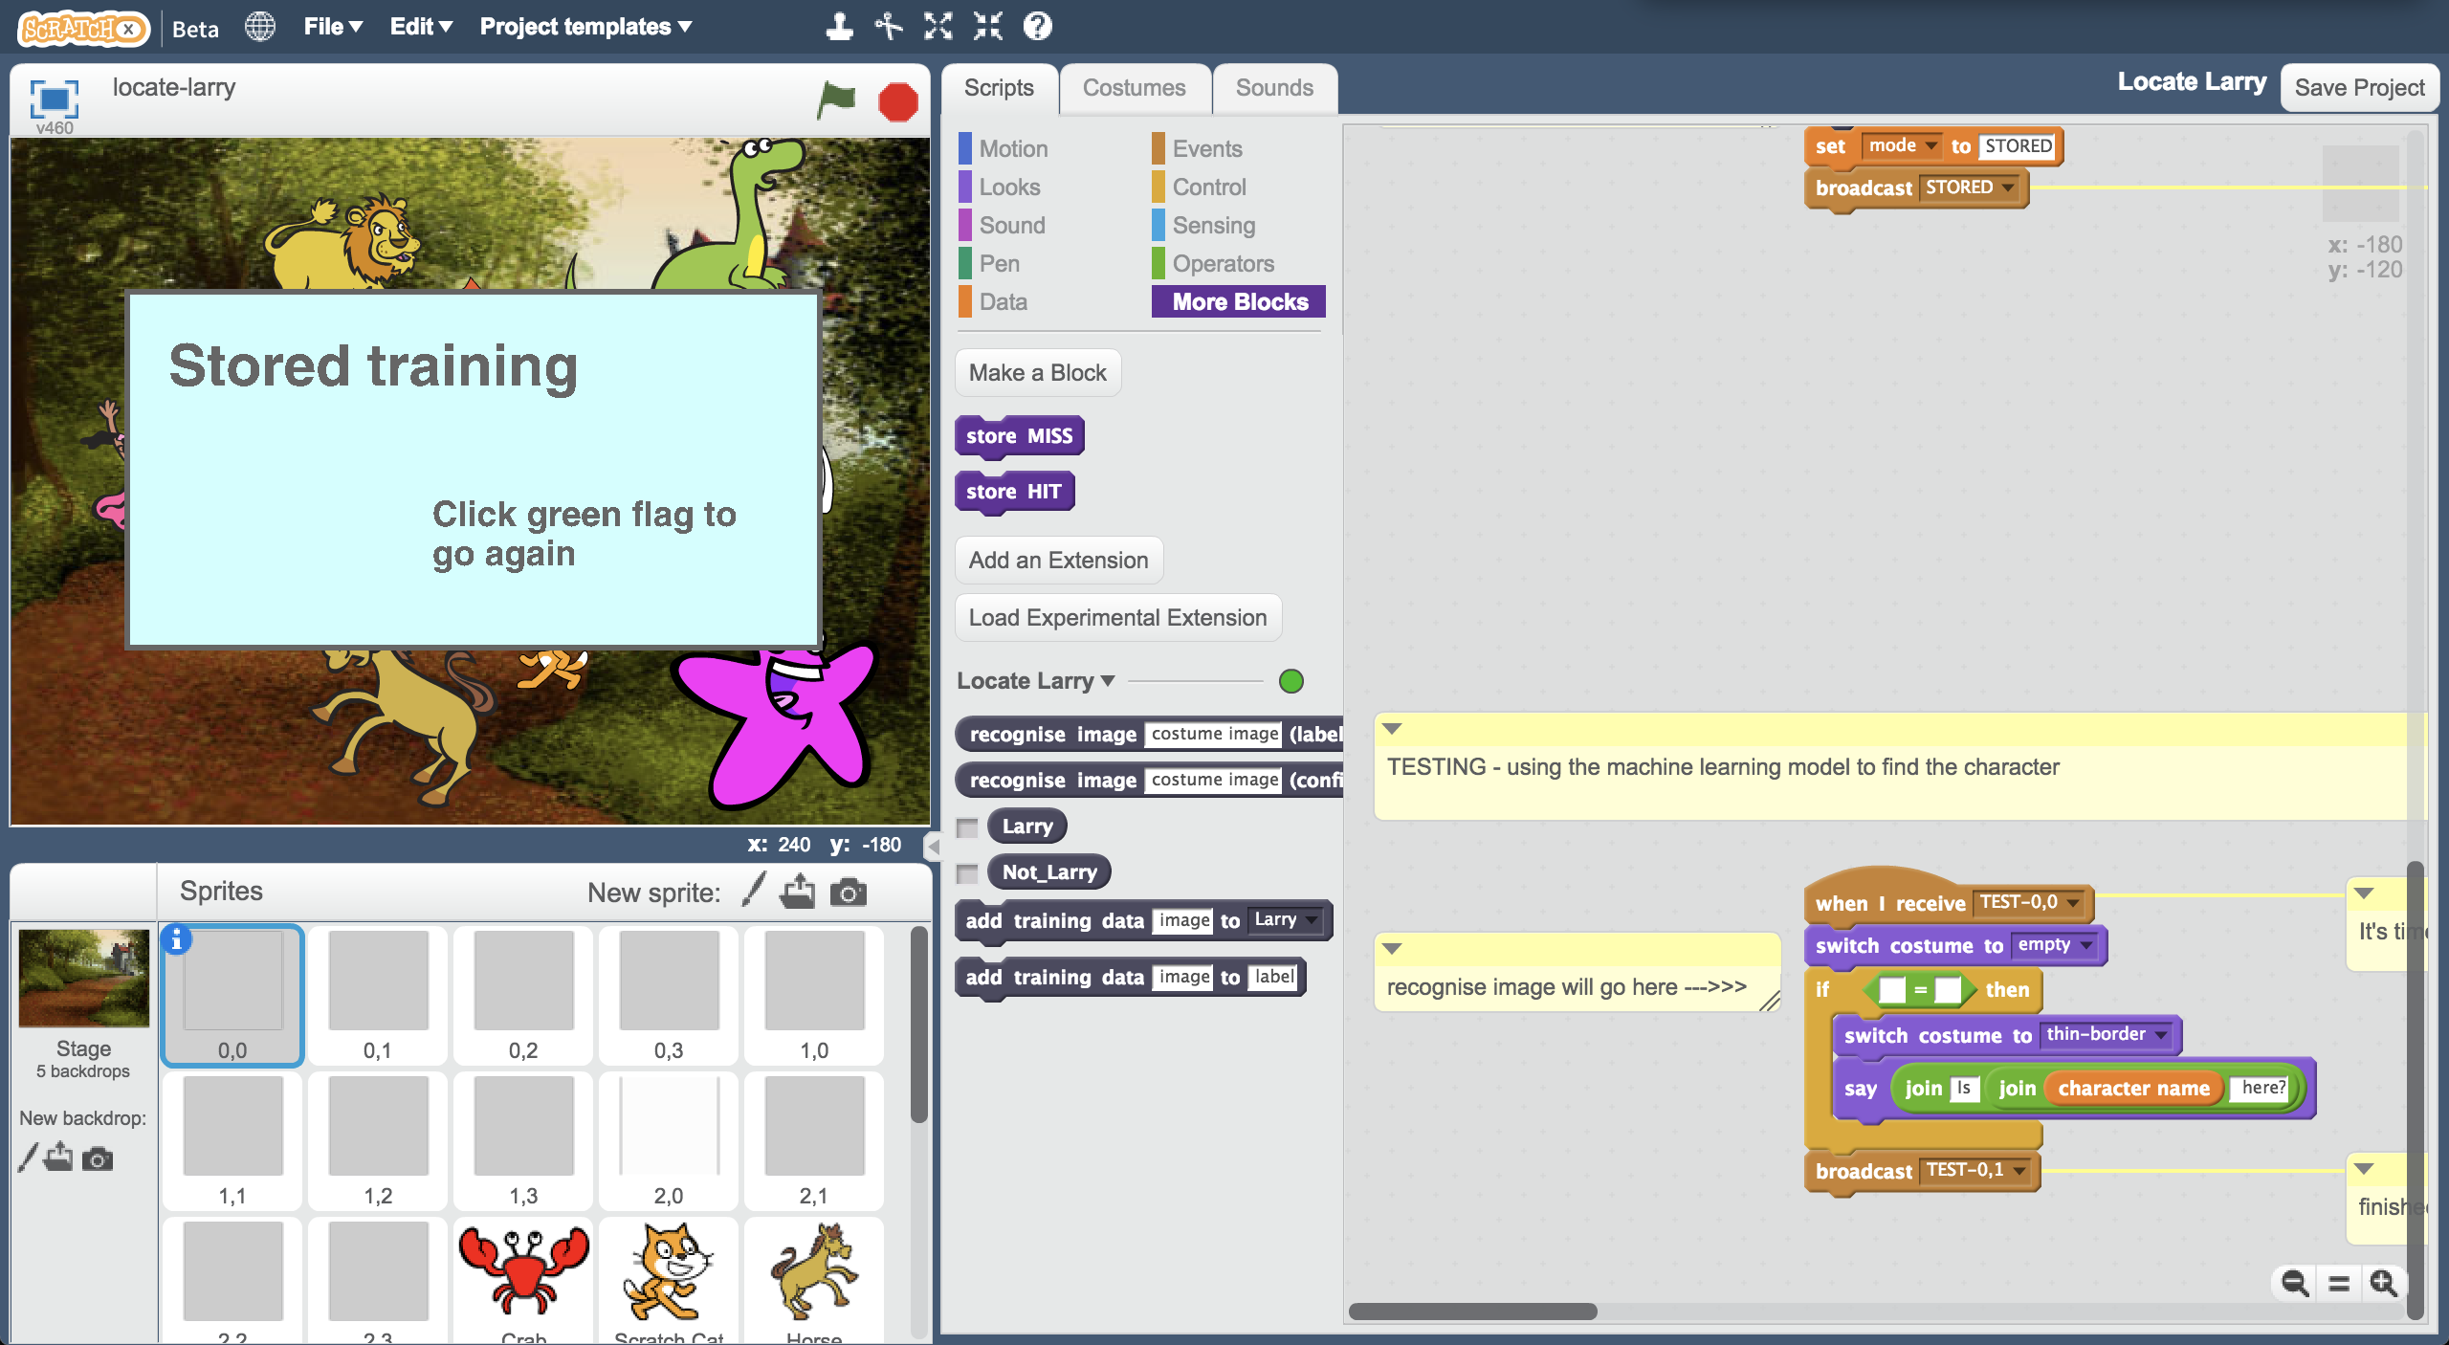
10. Update the script to look like this  
    *The comment “recognise image will go here” is there to help.   
    You need to add the “recognise image”, “backdrop image” and “Larry” blocks.*   
    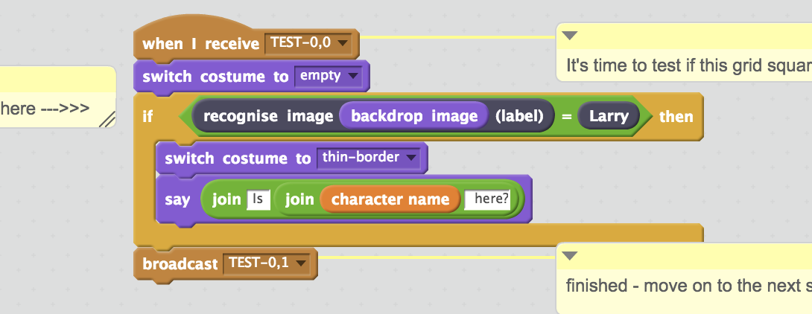
11. Click on the “0,1” sprite, and do the same again  
    *As before, there are three blocks you need to add:   
     “recognise image”, “backdrop image” and “Larry”*  
    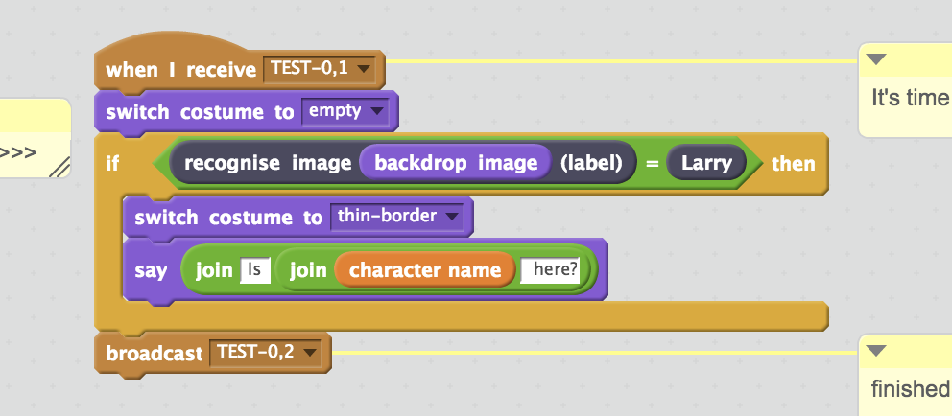
12. Do that again for all the other grid square sprites:  
    0,2 0,3 1,0 1,1 1,2 1,3 2,0 2,1 2,2 2,3  
      
    Make sure you do all twelve sprites that look like grey squares!
13. It’s time to test!  
    *Click the “full-screen” button, and then click the Green Flag.*   
    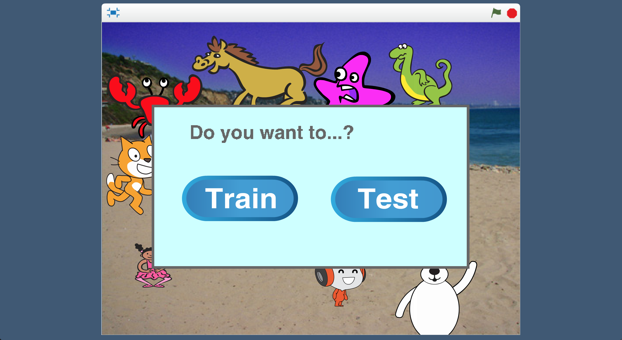
14. Click “**Test**”  
    

1. Did it work?  
   *Try it a couple of times and see how good it is at finding your character.*
2. If it’s not getting it right, click the Green Flag and then click Train a few times to collect more examples. *You* ***need to train a new machine learning model again*** *to use the new examples.   
     
     
   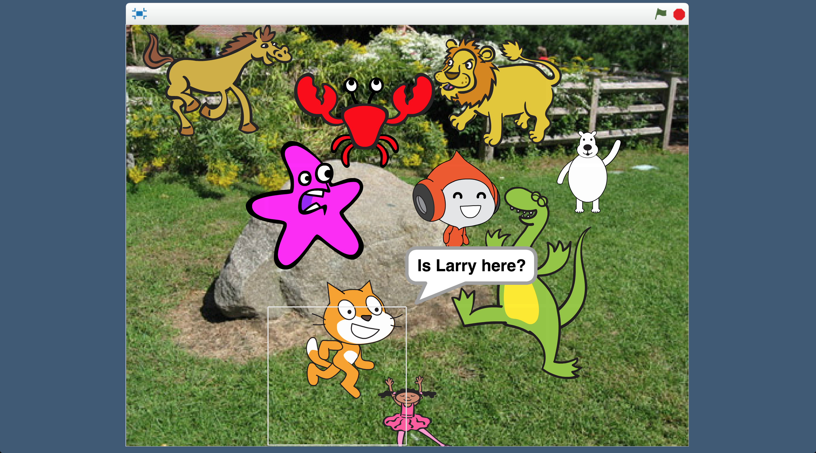*

**What have you done?**

You’ve trained a machine learning model to be able to recognise a character in a picture.

You don’t just want to know if the character is in the picture, but where in the picture they are. To do this, the picture was cut up into twelve squares, and you used the machine learning model to check each of the twelve squares individually.

**Did you know?**

What you’ve made in Scratch is a common approach for finding things in pictures.

**Street sign Captchas**

Have you ever been asked to complete a “captcha” as part of logging into a website? Clicking on squares in a photo that contain street signs is a common one.

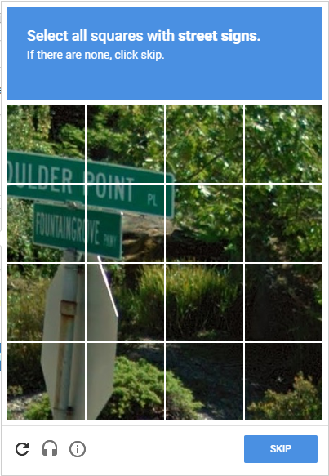

As well as proving that you are a human, this is very similar to what you made in this project: you are helping to train a machine learning model to recognise and find street signs.

Do you think this could be useful to help with the development of self-driving cars?

**Quickly understanding water usage in times of drought**

In 2015, during a state of emergency caused by a drought in California, a machine learning model was used to find lawns, swimming pools, & other features that affect water usage.

By cutting the satellite images for the whole state into small squares, each one could be individually classified. Combining this with a map meant they could quickly understand the impact on water usage across the state.